New Life in the Old House, Thomas Nast, 1901
by Nancy Hall and Charlotte Miska

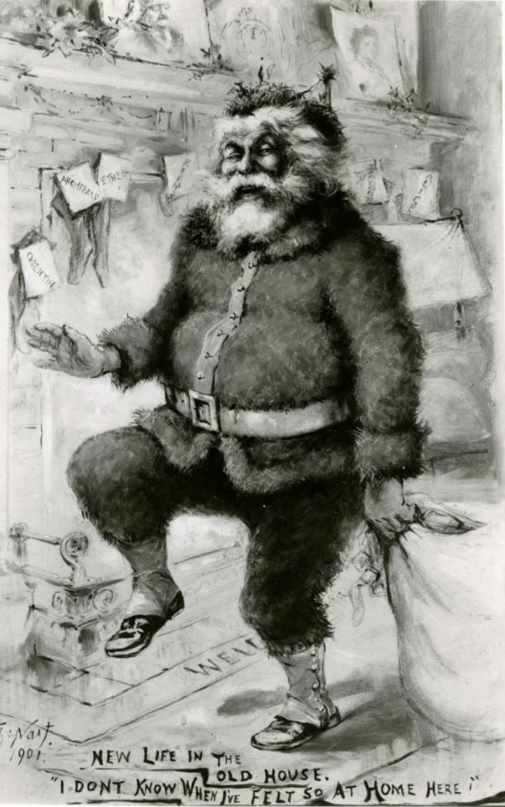

Christmas, 1901 – Just a little over three months since he took the oath of office, President Theodore Roosevelt and his family celebrated their first Christmas in the White House. While Americans were generally used to seeing the Roosevelts in our nation’s capital, the prospect of a tribe of rambunctious children living in the Executive Mansion (not yet called the White House) energized a nation worn out by the recent tragedy of President McKinley’s assassination (and for those of us old enough to remember, a similar excitement was felt by the public in 1960, when John Kennedy’s young family moved into 1600 Pennsylvania Avenue).

In the spirit of the season, famed cartoonist, Thomas Nast, recently jobless and nearly broke, presented TR and his family with this now iconic drawing of St. Nicholas in return for Roosevelt’s having appointed him Consul General of Ecuador. (It seems that St. Nick was not the only giver of gifts that year.) A close look at this famous depiction of jolly, old St. Nick shows the names of the Roosevelt children on each of the stockings, portraits of TR and Edith on the mantle, and a twinkling Santa whose face bears a striking resemblance to the president himself who says, “I’ve never felt so much at home here.”

